Project Design Phase-IITechnologyArchitecture

|  |  |
| --- | --- |
| Date | 14.10.2022 |
| TeamID | PNT2022TMID17177 |
| ProjectName | Project-Smartfarmer-IOTenabledsmartfarmingapplication |
| MaximumMarks | 4Marks |

TechnologyArchitecture:

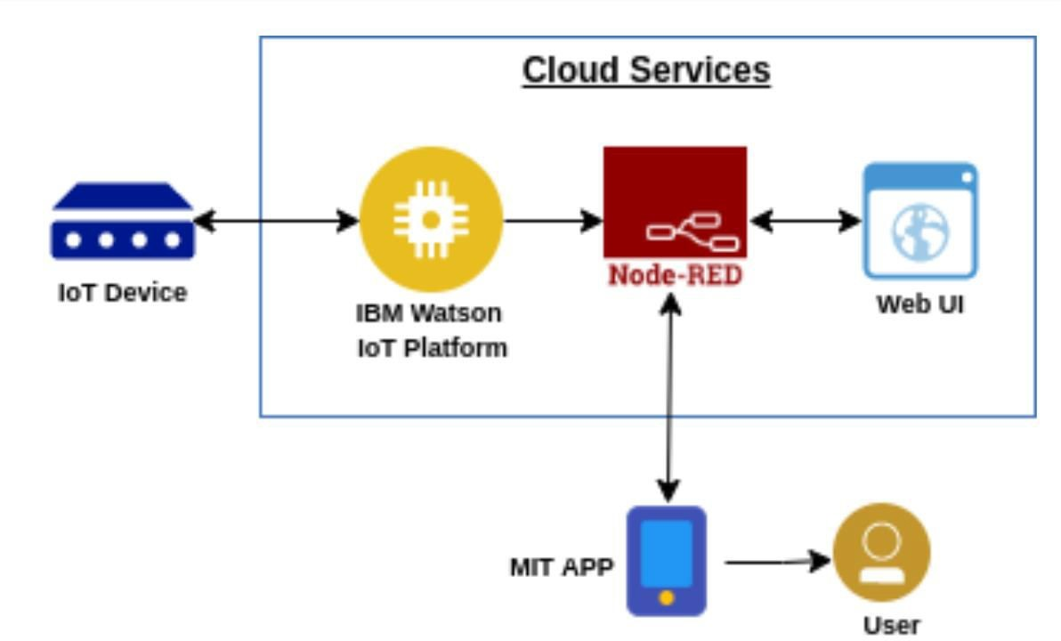

**IOTDevice-**IoTdevicesincludecomputerdevices,software,wirelesssensors,andactuators

**IBMWatsonIoTPlatform-**IoTdevicesincludecomputerdevices,software,wirelesssensors,andactuators**.**

Node-RED-Node-REDisaprogrammingtoolforwiringtogetherhardwaredevices,APIs andonlineservicesinnewandinterestingways

WebUI-TheWebUIisastreamlinedWeb-basedapplicationwithauser-friendly interfacethatallowsyoutoeasilymanagetheNetScreenappliance.

MITApp-AppInventorisacloud-basedtool,whichmeansyoucanbuildapps rightinyourwebbrowser.

User–Useristheonewhousesthesoftware.